**The application of the case study research in Design thinking**

*Asieh Mirzabagherian*

HPI University, Germany

Mirzabagherian.asieh@gmail.com

*Literature Review*

1. **Introduction**

Case study research (CSR) has become much more popular (Ridder,2017 and Eisenhart, 1989, 2007), especially in new topic areas such as Design thinking (e.g. google scholar about 26.300 results). the frame-breaking insight exploration, the theory Evaluation (e.g., parsimony, logical coherence), and the evidence grounding confirmation (Eisenhart, 1989) can be named as the reasons for this fact. CSR can embrace several methods while building, developing or testing procedures of research theory. Consequently, it can attract a wider audience who may not even be predicted beforehand (Yilkoski, 2019). This holistic research approach is methodologically flexible enough (Merriam (1998,2009)) to go beyond the exploration or confirmation (Ridder, 2017); it can be applied not only for defining the point of view in Design thinking (Clune ,2014) but also in co-creation preferences (Scheer, 2012). This multi-function approach (Ridder, 2017) is debated and applied through decades while it can cover different aims of specific research. However, this variation may lead to confusion for its application (Harisson, 2017). In order to shed light on its wide application especially in DT and fill this gap, this paper aim at providing a framework to simplify its application. Respectively the research questions of this study are “what are the Theory-based CSR types?” and” How are the application conditions and criteria of each one in DT?” Consequently, based on two important features of CSR, three design types will be presented (section 2-2) and eventually as evidence, some relevant DT scholars are analyzed for clarifying the requisite tenets of designing a case study.

**Theory-based CSR design**

1. **CSR- History**

The contemporary case study is originated in anthropology and social sciences (JOHANSSON, 2003, MERRIAM, 2009; SIMONS, 2009; STEWART, 2014) and they were conducted in the natural setting of those experiences with descriptive results (MERRIAM, 2009). Although this approach has been widely applied by the scientist for qualitative research, in the late 1940s and 1950s (Harisson (2017), following the quantitative research trend (JOHANSSON, 2003), which applied mostly for an empirical study on a specific phenomenon (MERRIAM, 2009). Afterward, the advent of grounded theory methodology had its own qualitative impact on data analysis of CSR researchers (GLASER & STRAUSS, 1967). Certainly, Robert YIN with his background in social science, introduced a process for conducting qualitative case study research. YIN, 2014). The other step for empower CSR was the integrated methodological approach which stems in political science. This happened particularly during the 1980's and 1990’s for the sake of developing and testing the theory (GEORGE & BENNETT, 2005). Following Yin approach, the importance of a theoretical framework or the research questions was promoted by other researchers as a guide for the research process and a systematic data collection (MERRIAM, 2009) and (Eisenhart, 1989).

Harisson (2017) declared that over the last forty years, CSR “has undergone substantial methodological development” which can be rooted in either different transformation research approaches or researchers’ preferences and interpretations. Although this flexible feature of an approach could be one of its strengths, this variety of contributions led CSR in a complex condition from the definition and application. The following discussion will present a framework as a clue for this complexity.

1. **CSR- Definition and approach**

As explained beforehand, CSR is applicable across various disciplines. Consequently, the reviewed literature conducted by this section is not restricted by any discipline area, but their number of citations has for the sake of this study’s credibility.

Reviewing named articles, we came across some definitions and approaches which support or complete each other. Case study is named as a methodology or a method, an approach, research strategy or research design, and a form of inquiry (ANTHONY & JACK, 2009; BROWN, 2008; CRESWELL, 2014; Eisenhart (1989); GERRING, 2004; MERRIAM, 2009; SIMONS, 2009, STAKE, 1995, 2006; STEWART, 2014; YIN, 2014). Eisenhart (1989) declares the case study is “a research strategy which focuses on understanding the dynamics present within single settings”. Depending on the phenomenon and its setting different prepositions are assumable which can be called a theory (Alvesson and Ka¨rreman 2007; Bacharach 1989; Dubin 1978; Kaplan 1998; Suddaby 2010; Weick 1989, 1995; Whetten 1989). Ridder (2017) discussed 4 four popular case study research pioneers, Eisenhardt (1989, 1991), Yin (2003), Stake (1995), Burawoy (1991), to shed light on the contribution of the theory and the case study design which is adopted for presenting the approach of this study. Aiming at reducing the confusion this multi-facet approach, the following is divided into two subsections with two important concepts for conducting a CSR are discussed.

2.1 CSR Sampling strategy

There is a wide range of sampling types and strategies (Patton, 1990, pp.182-183), being of research interest (Stake 2005), and theoretical relevance (Eisenhardt and Graebner 2007) are just two reasons why a researcher should decide on the sampling type and strategy for his/her CSR. For a better decision which leads to a better CSR design, two issues are important:

* Appropriateness: it should be fit to both the purpose of the research and the phenomenon of inquiry; to fulfill this issue, the researcher has to know how to sample the case studies. (Kuzel, 1999; Miles and Huberman, 1994; Patton, 1990)
* Adequacy: it is related to how many cases are enough. In this regard, Kuzel (1999) suggested a flexible selection of the cases in addition to saturated information of evidence and a rich explanation of the cases.

One of the most popular guidance on case study types and the strategy to apply them is conducted by Yin (1994). He divided selection strategies for the single case and multi-case which are referred by the number of reviewed literature. Some of these strategies will be mentioned in the framework of this study.

2.2 CSR theory spectrum

Across the literature, there are various views and descriptions of the CSR theory, however, the most abstract but comprehensive one from this study point of view is declared by Corley and Gioia (2011) ‘‘… theory is a statement of concepts and their interrelationships that shows how and/or why a phenomenon occurs’’. According to this definition, we can have an imagination of the relationship of each element of the theory and the observed phenomena.As a result, theory comprises three basic elements (Alvesson and Ka¨rreman 2007; Bacharach 1989; Dubin 1978; Kaplan 1998; Suddaby 2010; Weick 1989, 1995; Whetten 1989):

* Concepts and constructs: “concept” is more general and descriptive while” construct” is more specified and operational. (Gioia et al., 2013; Ridder, 2017)
* Relationships between concepts or constructs: the underlying how and whys for explaining or predicting the behavior of a specified set of phenomena (Weick, 1995)
* Boundaries /setting (temporal and contextual) which affects the generalizability of the theory.

This theory cycle is described as a continuum than a product (Weick, 1995) or a process than an outcome (Gilbert and Christensen, 2005). This process will start with a careful description of phenomena, then classification in the similar phenomena category. After that, researchers can specify a model for the 3 elements of the theory i.e. what factors drive the phenomena and under what circumstances. The categorization scheme will assist the researchers in their predictions or confirmations. (Gilbert and Christensen, 2005).

Following Ridder (2017), we name this process as the “theory spectrum”. This spectrum comprises 3statuses: Building, Developing, and Testing. To build more on this concept, Ridder (2017), presented a comparison of CSR’s design and their theory contributions. Although his study is so comprehensive among the reviewed literature, it cannot be considered as simple guidance to bridge the high possibility of confusion of interested researchers. Therefore, building upon his results and combining other helpful literature, an applicable framework for multi-disciplinary fields with the focus on the design thinking application is suggested.

Base on the phenomenon and theory relations, a CSR can experience through 3 different theory status; Diagram 1 is a depiction of different CSR process based on them. Following the condition of the decision of utilizing each of them is provided.

*Building*

In this phase of the spectrum, the researcher has an assumption of the phenomena (Yin, 1994) and s/he wants to create a theory based on his/her interpretation. Respectively, the eliciting of concepts, relationships, and prior constructs are crucial in defining the research strategy. This exploration is aiming at the generating of tentative theories. The research strategy is synced with an investigation of a new phenomenon, so the protocol will be detailed descriptions of the phenomenon of existence (how and why) (Ridder, 2017). Data collection is based on triangulation, (Burns 2000; Dooley 2002; Eisenhardt 1989; Ridder 2016; Stake 2005: 454) and draws from multiple sources such as observations, interviews, archival records or documents, physical artifacts, and audiovisual materials. (Williams,2007; (Flick 2009: 257; Mason 2002: 84). In a single case study researcher will expand constructs and relationships within a distinct setting (in-case analysis) while in multi-case cross-analysis, s/he compares similarities and differences among cases case respectively the result of first is creating theory and the second advancing the theory by revealed emerging patterns (Ridder, 2017). The confirmation on the constructs as the research progress can lead to replication or corroboration of propositions (Eisenhardt 1991; Eisenhart,1989). These within-case patterns and cross-case patterns can eventually lead to a new theory (Ridder,2017).

*Developing*

This process will start with a tentative theory that can provide a “lacks and gaps” (Ridder,2017) of existing theory demonstration and respectively some predictions on the existing literature and the preexisting constructs will be confronted by pattern-matching[1]. This CSR design type aims at theory extension or modification (Edmondson and McManus 2007); thus during the investigation, new theory-based propositions will be developed for evaluation of the elements, relationships, and mechanisms. Therefore, as a theoretical refinement, this process will add a new component to the existing construct/ concept. Furthermore, with Data triangulation, the researcher can narrow down the problems of construct validity, by using multiple measures of the same phenomenon (Ridder,2017).

*Testing*

In this status, the research question is more precise while the constructs and relationships are well developed and mature based on the previous variables, therefore, measuring of the propositions will conduct precisely. Having specific testable hypotheses, the researcher is capable of testing the predicted relations in a clearly defined condition, e.g. time and space (Gilbert and Christensen, 2005) with the quantities data analysis. This kind of research is applicable both with single case study and with multiple one, in the first one confirmation or challenging the theory and for the second theoretical replication will reveal the pattern-matching. The research strategy is with rival theories, different conditions and circumstances (Ridder, 2017).

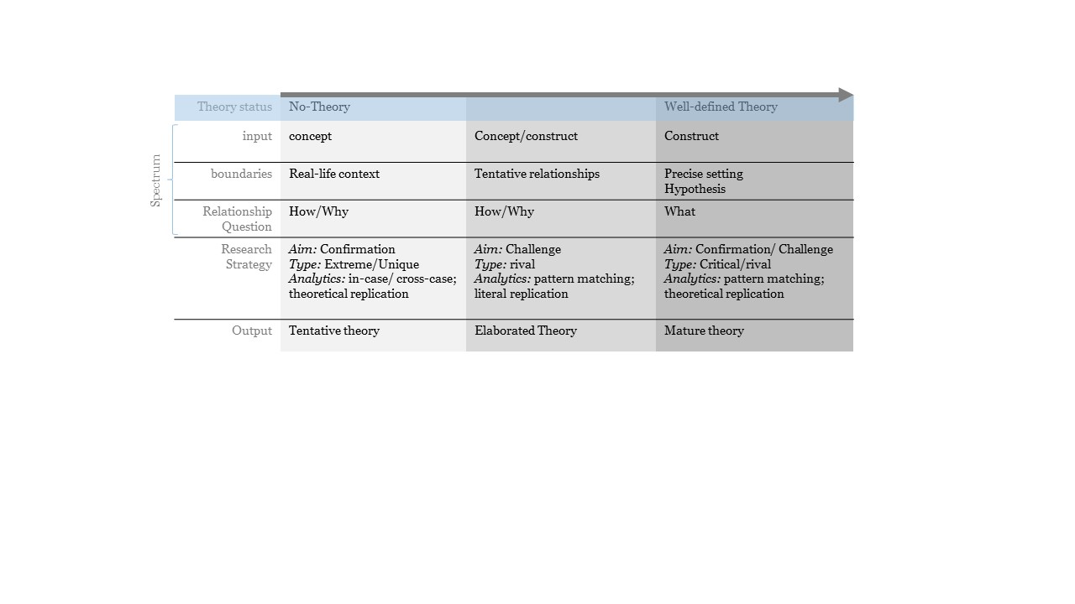

Diagram1. Interplay of theory spectrum and CSR design elements

**3 CSR- application**

CSR is one of the popular methodologies in Deign thinking(DT) since the relations of the phenomena in this researches are complex or “wicked”. There are a lot of characteristics in common to both approaches, CSR and DT, such as flexible method selection and explorative and analytic goals. In this section not only for attempting to present the DT study examples which applied but making a better contribution of previous sections for this study reviewers. Hence a proper time was dedicated to exploring a better interaction of findings by reviewing almost 50 founded abstracts of the two Databases ‘Google Scholar” and “Science direct” in the first step. Since most of the reviewed abstract did not contain the CSR design elements such as boundaries or the research strategy, we decided on conducting the second phase with the analyzing the full text of the first ten related articles of each database. Among them, the final reviewed articles were limited to the open-source papers depicted in table 1.

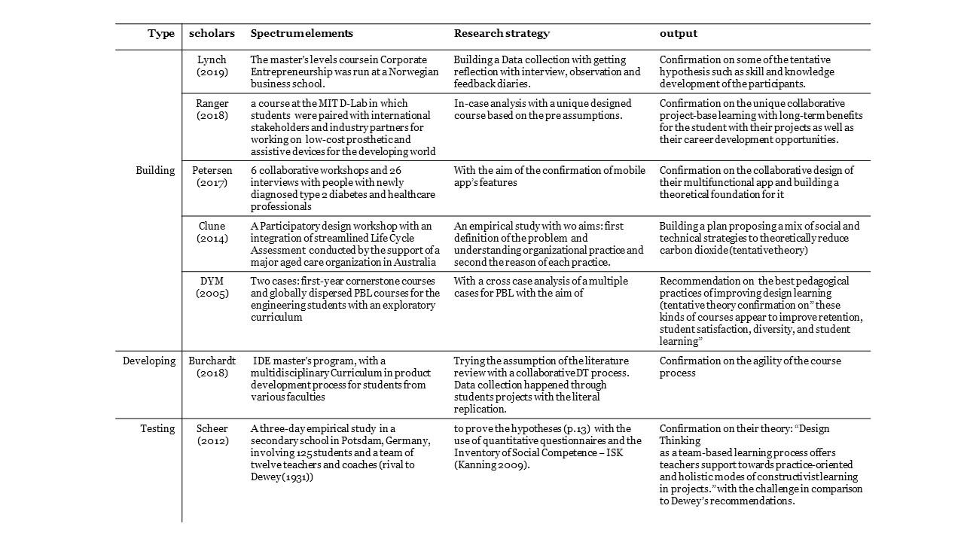

Table-1 Representative scholars of Applying CSR in DT

Most of these articles are attempting to improve the pedagogy in different disciplines such as entrepreneurship (Lynch, 2019) or engineering (DYM, 2005) by Design thinking approach for their exploratory course or workshop. On the other hand, some take the DT methodology for conducting their research as a design thinking project(Petersen,2017). The setting of the cases varies from a workshop (Petersen,2017) or university courses (Burchardt (2018), Ranger, 2018) to a real project of a company. (refs). All of these researches have their aim to conducting their research in different boundaries. These scholars represent that most studies utilized CSR mostly for shaping a tentative theory and the common method among most of them are interview and observation. However, the participatory approach can be seen among them mostly because of the DT approach which leads to a better theory.

**4 Conclusion**

CSR is a valuable way of research in every field including DT while it is capable of investigation a phenomenon in its real-life context. Theory-based CSR design types give the researchers the opportunity of selection based on their interests or needs. The range of different Data collection methods and the possibility of mixture of quantitative and qualitative data analytics empower the researchers to design their research freely. However, for a better result and less theory confirmation failures, the suggested framework would be helpful for leveraging the pace of the CSR process.

This paper presents part of a larger study that seeks to investigate the potential of the Design Thinking (DT) approach for the innovation processes. However, this study attempted to uncover relevant sources for the aim of providing a literature review on Theory-based CSR types and the application conditions of each in DT. The recommended framework contains the vital criteria of theory-base CSR to increasing the awareness the interested researchers. However, gaps in the studies are inevitable and in this study, since the in findings of DT representative CSR is the researcher’s interpretation, it might be different slightly from the CSR experts’ point of view. Respectively, further investigation would be helpful for a richer literature in this area.

**5 References**

Dewey, J. (1931): Ausweg aus dem pädagogischen Wirrwarr. Inglis Vorlseung 1931. In: Petersen, P. (Ed.)

(1935): Der Projekt-Plan. Grundlegung und Praxis von

John Dewey und William Heard Kilpatrick. pp. 85-101.

Weimar.

Eisenhart, K. 1989. “Building Theory from Case Study Research,” Academy of Management Review (14:4), pp. 532-550. (<http://www.jstor.org/stable/258557>)

Eisenhart, K. Graebner, M. 2007. “Theory Building from Cases: Opportunities and Challenges,” Academy of Management Journal (50:1), pp. 25-32.

Rowley, J. 2002. “Using Case Studies in Research,” Management Research News (25:1), pp. 16-25.

Ylikoski, P. 2019. “Mechanism-based Theorizing and Generalization from Case Studies,” Studies in History and Philosophy of Science (78), Elsevier, pp. 14-22.

Ridder, H. 2017. “The Theory Contribution of Case Study Research Designs,” Business Research (10), Springer, pp. 281-305. (<http://hdl.handle.net/10419/177270>)

Burawoy, M. 1998. The extended case method. Sociological Theory 16: 4–33.

Flick, U. 2009. An introduction to qualitative research, 4th ed. London: SAGE.

Mason, J. 2002. Qualitative researching, 2nd ed. London, Thousand Oaks: Sage Publications.

Weick, K.E. 1989. Theory construction as disciplined imagination. Academy of Management Review 14: 516–531.

Gilbert, C.G., and C.M. Christensen. 2005. Anomaly-seeking research: thirty years of development in resource allocation theory. In From resource allocation to strategy, ed. J.L. Bower, and C.G Gilbert, 71–89. Oxford: University Press, Oxford.

Gioia, D.A., K.G. Corley, and A.L. Hamilton. 2013. Seeking qualitative rigor in inductive research: note on the Gioia methodology. Organizational Research Methods 16: 15–31.

Yin, R.K. 2014. Case study research. Design and methods, 5th ed. London, Thousand Oaks: Sage Publications.

Harrison, K. 2017. “Mechanism-based Theorizing and Generalization from Case Studies,” Forum: Qualitative Social Research (18:1), Elsevier, pp. 14-22.(<http://www.qualitative-research.net/index.php/fqs/article/view/2655/4079>)

World Economic Forum 2018. “The Future of Jobs Report 2018,” *Insight report,* Centre for the New

Economy and Society; Weltwirtschaftsforum, Cologny/Geneva.

Williams, P. 2007. “Research Method,” Journal of Business & Economic Research (5:3), pp. 65-71.

Creswell, J. 2003. “Research design: Qualitative, quantitative and mixed methods approaches,” (2nd ed.). Thousand Oaks, CA: SAGE Publications.

Leedy, P. & Ormrod, J. 2001. “Practical research: Planning and design,” (7th ed.). Upper Saddle River, NJ: Merrill Prentice Hall. Thousand Oaks: SAGE Publications.

Shakir, M. 2002. “'The selection of case studies: Strategies and their applications to IS implementation cases studies,” Res. Lett. Inf. Math. Sci. (3), pp. 191-198. (<http://www.massey.ac.nz/~wwiims/research/letters>)

Miles and Huberman, 1994; Miles, M.B. and Huberman, A.M. Qualitative Data Analysis: An Expanded Sourcebook, Sage Publications, Thousand Oaks, 1994.

Patton, 1990 Patton, M.Q. Qualitative Evaluation and Research Methods, Sage Publications, Newbury Park, California, 1990.

Kuzel, A.J. 1999; "Sampling in Qualitative Inquiry," In Doing Qualitative Research, B. F. Crabtree and W.L. Miller (Ed.), Sage Publications, Thousand Oaks, CA, 1999, pp. 33-45.

Creswell, J.W. Research Design: Qualitative and Quantitative Approaches, Sage Publications, London, 1994.

Scheer A. Noweski C. Meinel C. 2012 Transforming Constructivist Learning into Action: Design Thinking in education; Design and Technology Education: An International Journal 17.3

DYM c. AGOGINO A. ERIS O. FREY D. LEIFER L. 2005; Engineering Design Thinking, Teaching, and Learning; Journal of Engineering Education; p.p. 103-120

Ranger B.J. Mantzavinou A. (2018) Design thinking in development engineering education: A case study on creating prosthetic and assistive technologies for the developing world; Development Engineering 3; p.p.166–174

Burchardt c. Maisch B. 2018. Advanced agile approaches to improve engineering activities; Carsten Burchardt et al. / Procedia Manufacturing 25 (2018) 202–212

CLUNE, S. & LOCKREY, S. 2014. Developing environmental sustainability strategies, the Double Diamond method of LCA and design thinking: a case study from aged care. Journal of Cleaner Production, 85, 67-82.

Lynch M. Kamovich U. Longva, KK. Steinert M. (2019) Combining technology and entrepreneurial education through design thinking: Students' reflections on the learning process Technological Forecasting & Social Change, https://doi.org/10.1016/j.techfore.2019.06.015

Petersen, M., Hempler, N.F. Development and testing of a mobile application to support diabetes self-management for people with newly diagnosed type 2 diabetes: a design thinking case study. BMC Med Inform Decis Mak 17, 91 (2017). https://doi.org/10.1186/s12911-017-0493-6

1. 2. pattern-matching: one of the most preferred techniques (Ridder, 2017) compare the theoretically based predictions with the empirical data in the site (Yin 2014);